**FY23 – R&D – [SPIKE] - Frontend – Personal Information Registration**

**Description**

**(Work in progress)**

As **an OM UI user**

I want to **create a personal information register**

In order to **keep it up to date in a specific registry for this purpose.**

**Premises:**

- Use DDS 2.0 Dell layout

- It must be developed in REACT language

**Rules:**

\***Option 1**:  List Personal Information:

* The system must display the Personal Information (Name, Surname, CPF, and Birthday. Action - Edit and Delete) that has already been added.

* System must display the following filters for the search:

- Search (Name or CPF)

* The system must display the buttons:

- "Add New Person"

Picture 1:

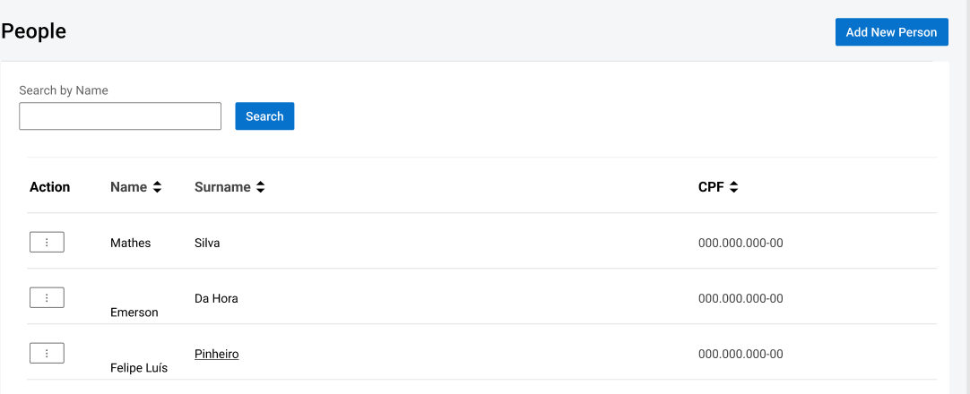

\***Option 2**:  Add New Person:

* When the user selects the button "Add New Person" the system must open the Add Person page so that he can enter with the information he fields:

Picture 2:

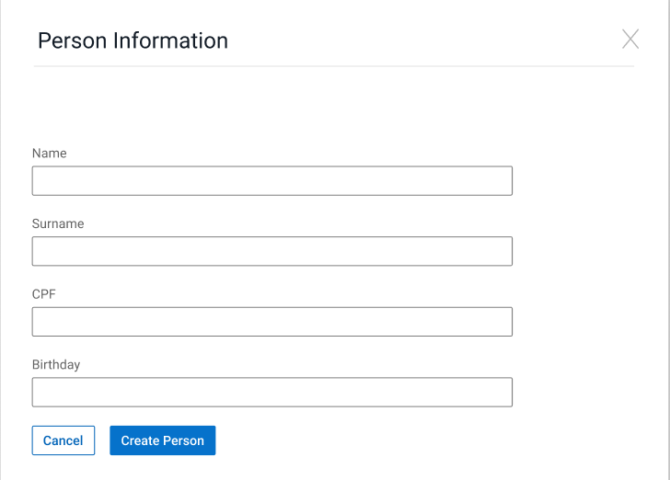

  - **Person Name**(Mandatory - Text Field - max size: 25 characters - must allow numbers, letters, and special characters)

  - **Person Surname**(Mandatory Text field - max size: 65 characters - must allow numbers, letters, and special characters)

-**Person CPF** (Mandatory Select Number - size: 65 characters - must allow only numbers)

* System must display the buttons below:

"Add" which saves all the person information into DB.

"Cancel" which discard the changes and redirects the user to the previous page.

*The system must not allow the user to include more than one register with the same Person CPF.

\***Option 3:**  Edit a person:

The system must show the selected Person fields filled with the Person information:

  - **Person Name**(Mandatory - Text Field - max size: 25 characters - must allow numbers, letters, and special characters)

  - **Person Surname**(Mandatory Text field - max size: 65 characters - must allow numbers, letters, and special characters)

-**Person CPF** (Mandatory Select Number - size: 65 characters - must allow only numbers)

And the buttons:

"Update" which saves all the person information into DB.

"Cancel" which discard the changes and redirects the user to the previous page.

\***Option 4:**  Delete Person:

* The system must allow the user to delete one person from the list:

* System must display the delete button in the "Action" column from the table

* When the user selects the delete button, the system displays the message "Are you sure you want to delete this person?" and the options "OK" and "Cancel".

- If the user selects the "OK" option, then the system must remove the person form DB

- If the user selects the "Cancel" option, then the system must cancel the action and keeps the user on the person list page

**Acceptance criteria**

**Scenario 1 ('Person' page):**

**Given**User logs on the system

**When**User clicks on the Person menu

**And** clicks on the Person submenu

**Then**a list with all the Persons must be displayed in the columns below:

- Name

- Surname

- CPF

**Scenario 2 (Search Person):**

**Given**User logs on the system

**And**User clicks on the Person menu

**And**the list with all the Person is displayed

**When**the user performs a search (Person CPF or Person Name Value)

**Then**the system must display in the table the information according to the search performed

**Scenario 3 (Add New Person into DB):**

**Given**User logs on the system

**When**User clicks on the Person menu

**And** a list with all the Persons must be displayed with the information described in Scenario 1

**And**Clicks 'Add New Person button

**Then**the system must redirect the user to add new person page with the fields below:

- Name

- Surname

- CPF

- Birthday

**And**user clicks on Save Button and the data is saved into person DB

**And**the system redirects to be displayed in the list of Existing Person updated.